014 TypeScript - interpolation

TypeScript Kata List – Blog Page

[TypeScript Kata List on GitHub](https://github.com/robertdunaway/katas-typescript)

# Duration

5 minutes

# Brief

Using string interpolation

### For More Information

BING/GOOGLE: “TypeScript interpolation”

# Instructions

Get tutorial folder or the entire katas-typescript repo.

Open the [before/*.sln] file and execute the kata.

Feel free to execute this kata multiple times because repetition creates motor memory.

# Github

* Before (start kata with this)
  + https://github.com/robertdunaway/katas-typescript/tree/master/014%20TypeScript%20-%20interpolation/before
* After
  + https://github.com/robertdunaway/katas-typescript/tree/master/014%20TypeScript%20-%20interpolation/after

# Kata

Replace the following with an interpolated string.

var firstName: string = 'Bob';

var career: string = 'programmer';

var newString: string = firstName + ' is a ' + career + '.'

console.log('classic string concatination');

console.log(newString);

The end result might look like this.

var newInterpString: string = `${firstName} is a ${career}.`;

console.log('string interpolation');

console.log(newInterpString);

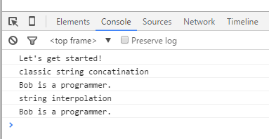

# Next

Take a few minutes and imagine more examples.